INVITATION TO BID

The Zamboanga City Electric Cooperative, Inc. (ZAMCELCO) through its Bids and Awards Committee (BAC) invites all interested parties to participate in the Bidding for the following items:

NO. | QUANTITY | ITEM DESCRIPTION
1 | 1 SET/S | CLAMP TESTER 3 IN 1
2 | 1 UNIT/S | CURRENT TRANSFORMER TESTER
3 | 3 SET/S | SWITCH, DISCONNECTING, 15KV, 600A

DETAILED SPECS FOR 1 SET CLAMP TESTER 3 IN 1:
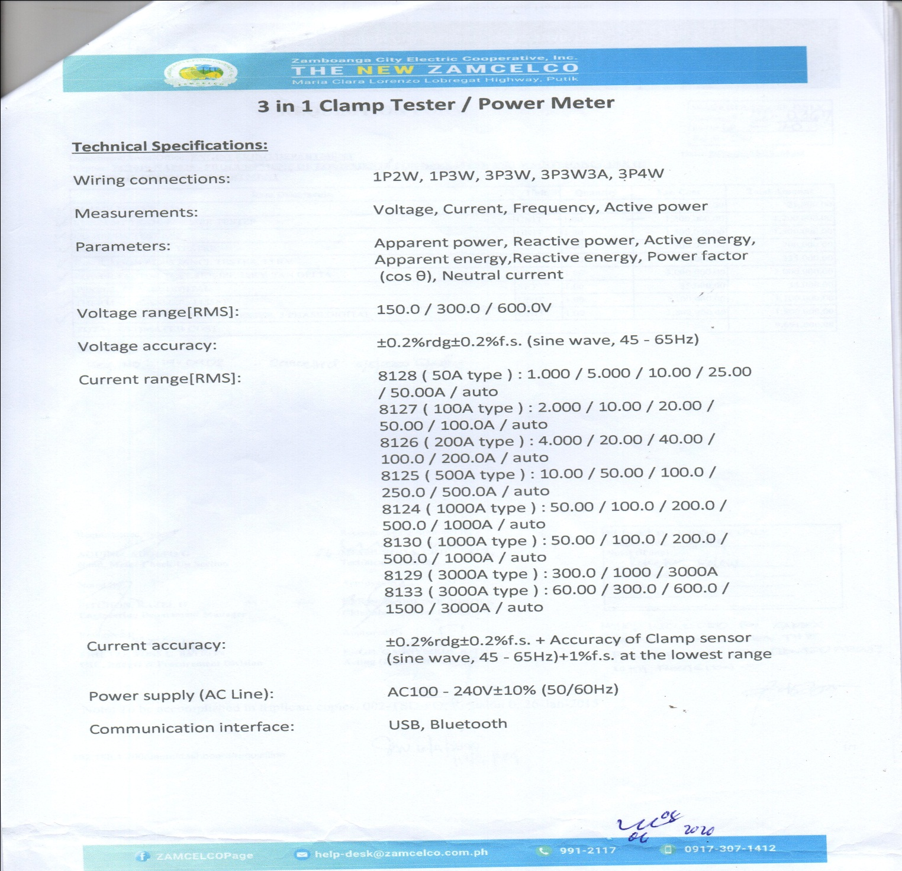

DETAILED SPECS FOR 1 UNIT CURRENT TRANSFORMER TESTER:
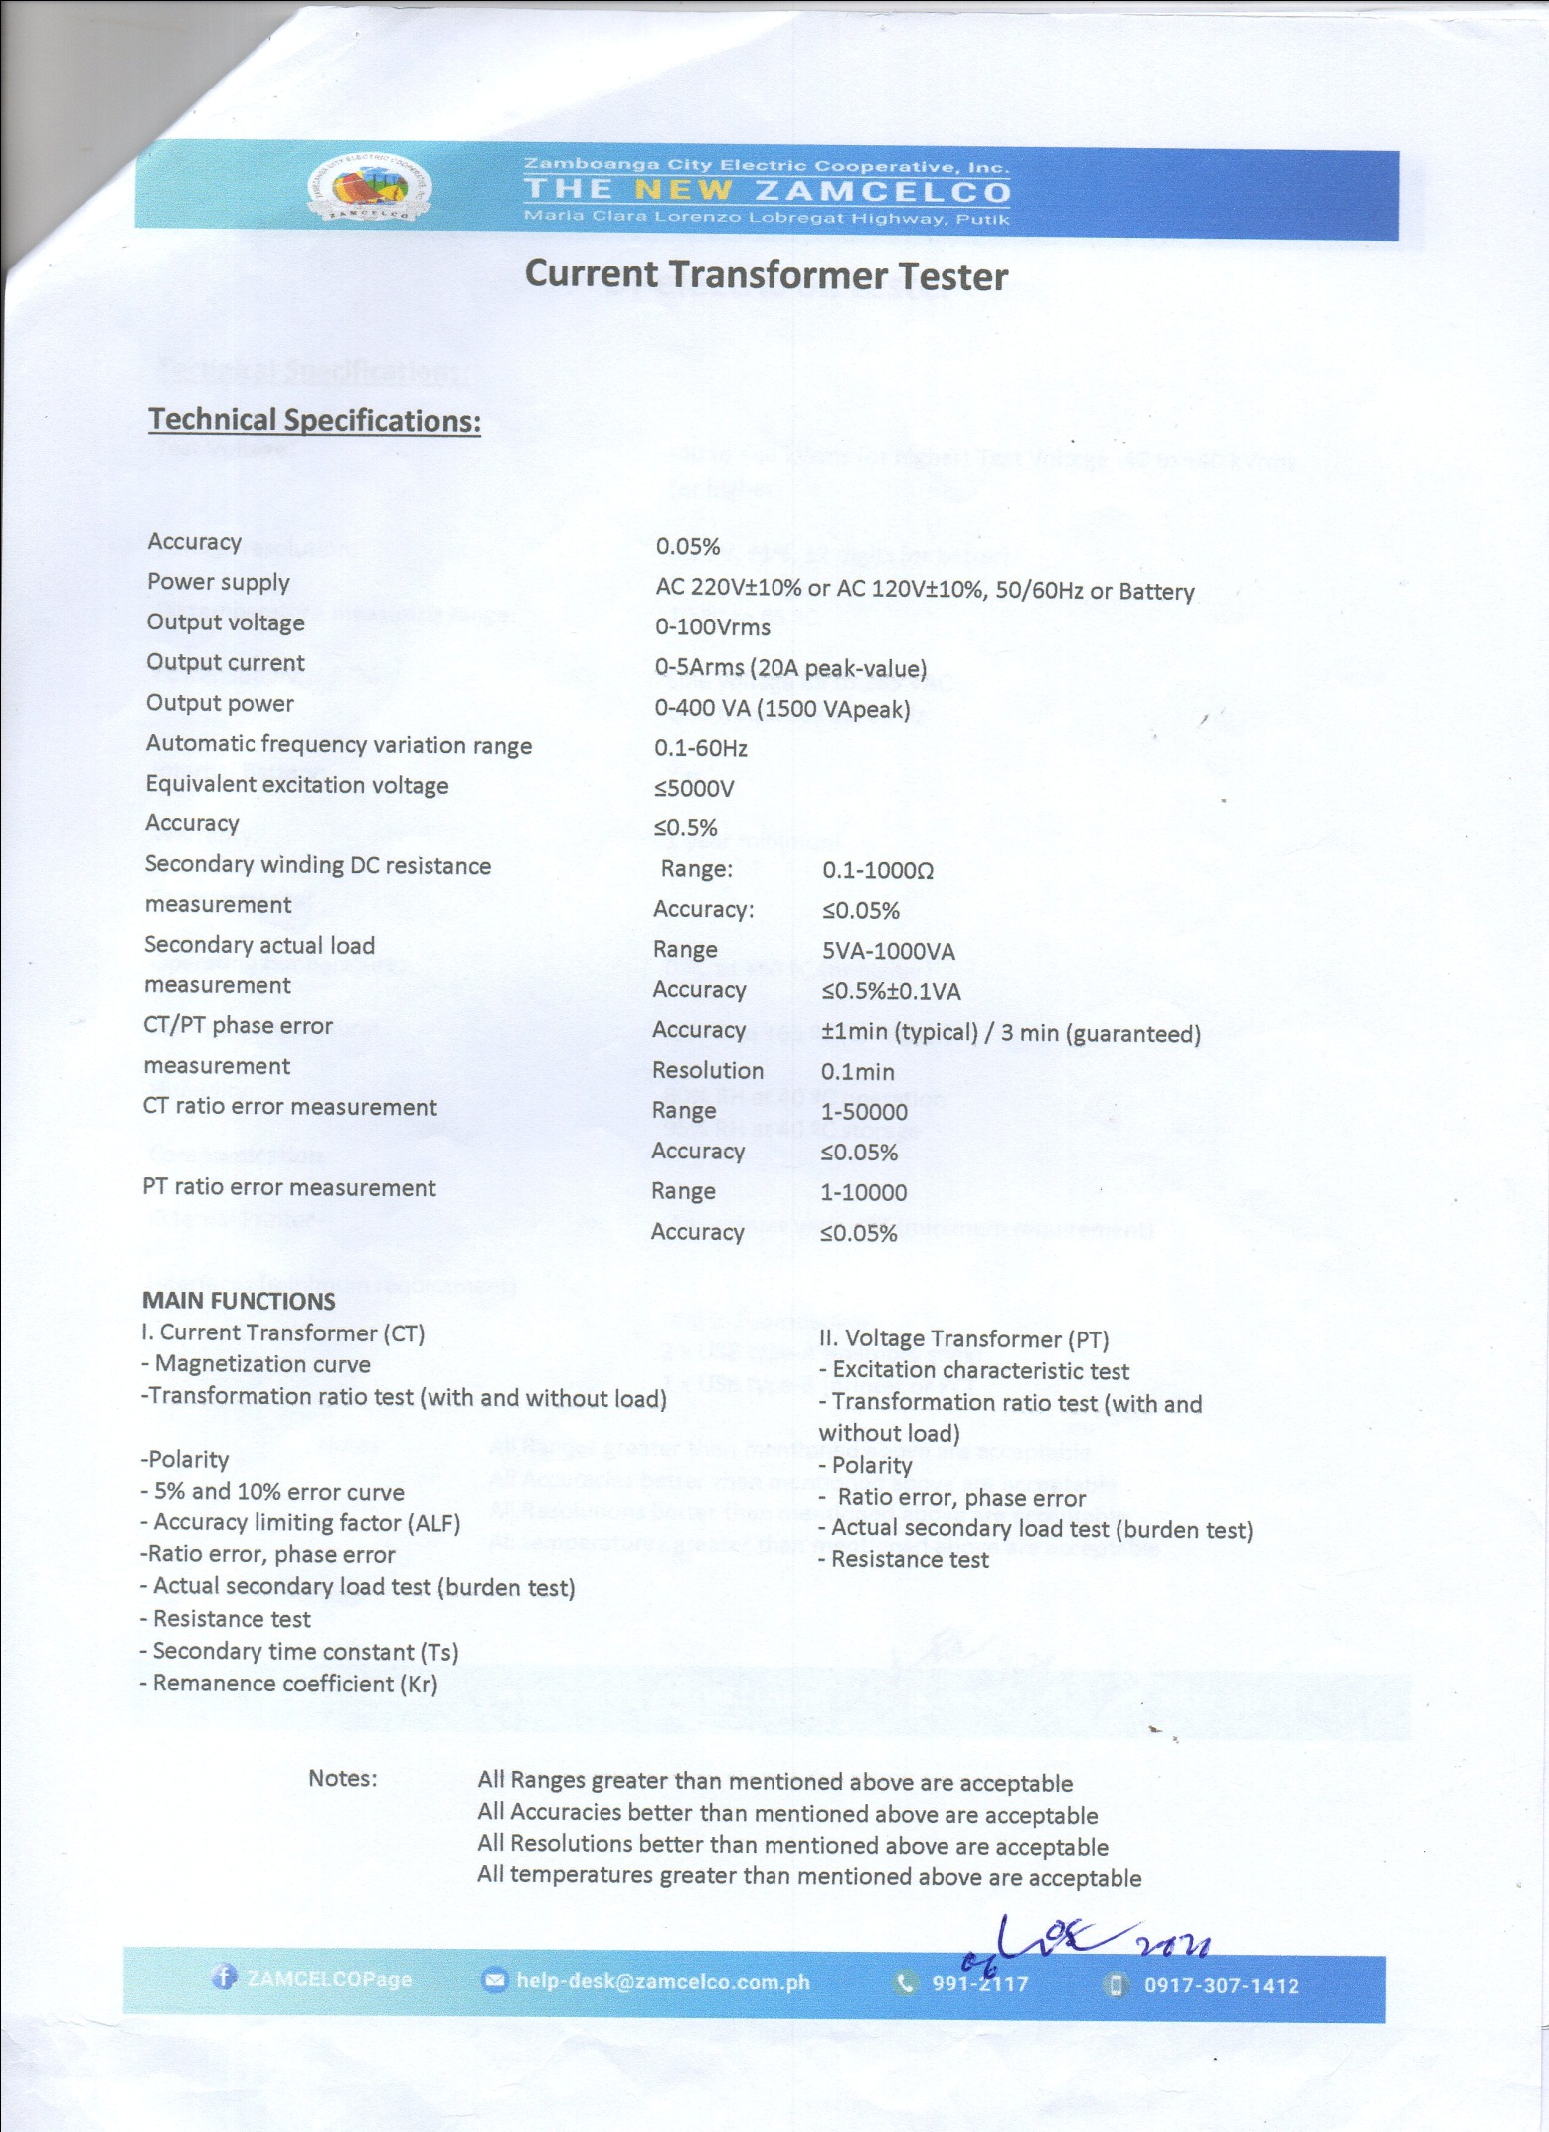

SAMPLE PHOTO OF SWITCH, DISCONNECTING, 15KV, 600A:

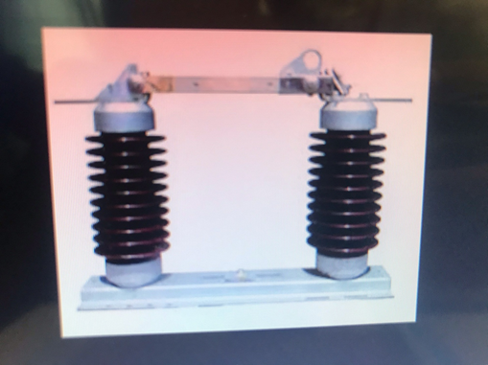
***Nothing Follows***

Notes:

- Interested bidders must submit their Bid proposals at Zamboanga City Electric Cooperative, Inc (ZAMCELCO), Putik, Main Office, Logistics Department, Procurement Division, Zamboanga City.

- For queries on detailed specifications of the materials listed above, please contact us at Email Address: procurement@zamcelco.com.ph, Tel. No. (062) 991-2117 local 8843, Cel no. 09173032620.

